SCLs or RGPs when to consider
  - Indications for CL wear: refractive error, cosmesis, presbyopia, irregular astigmatism, corneal dystrophies, amblyopia, nystagmus.
  - Indication for CLs vs Specs: high myopic script (cosmetic appeal), corneal astigmatism that cannot be corrected with spectacles, increase field of view, reduce ring scotoma (hyperope)/ring diplopia (myope), sports, heavy frame
  - For SCL: Better comfort due to softness, water content, larger diameter with edges resting to sclera, limited lens movement, SCL is easier to adapt to due to soft material creating less lid awareness upon blinking. Therefore, SCL should be prescribed for first time CL wearers. For therapeutic applications such as pain relief (i.e. bandage CLs), sport wear (more stable on the eye and less likely to dislocate or fall out as they are larger than the cornea)
  - RGP lenses have 1) Better clarity of vision, 2) lower overall cost as only need 1 pair of lenses for the whole year, less risk of infection, less prone to damage. 3) Extremely durable, 4) Less lens deposition, 5) Special conditions – Irregular cornea (corneal ectasias, corneal scars etc), Orthokeratology lenses, Mini-scleral lenses
Would try to give everyone SCL and only consider RGPs if px having issues with vision due to high cyl, Keratoconic pxs, those with irregular corneas (e.g. post-PRK).
RGPs better tear pump 10-15% tear exchange/blink, vs 1-2% exchange/blink with SCL.
  - How do CL help with patients that have nystagmus? There is a reduction in both amplitude and frequency of nystagmus with the theory that the feedback mechanism coming from the sensation of rigid contact lenses being in the eyes reduces this frequency and amplitude. However this is for a case to case basis.
  - Why do RGPs have less chances of infection compared to SCL? The Material plays a major role in the amount of microorganisms and bacteria that can be absorbed by the lenses- due to water content in SCL, the higher the water content the larger the pore size in hydrogel lenses so this absorbs substances more easily. On the other hand, RGP lenses do not have water content, meaning that these microorganisms are not absorbed as readily by the lenses. There is also greater tear exchange in RGP lenses due to the post lens tear film reservoir, which can wash out debris behind the lens. SCLs have minimal post lens tear film reservoir thus does not allow for debris to be easily washed out.
- What conditions should you be cautious of prescribing CL to? Blepharitis, pingueculae/pterygium, poor dexterity such as older pxs and those with arthritis, poor hygiene, poor environmental conditions, allergies, dermatological issues (e.g. acne rosacea, eczema), glaucoma (need to put drops in so ensure px waits 10-15 mins after inserting drops before putting CLs in), topical/systemic medications (hypertensives e.g. BBs reduce tear production, drugs for congestive heart failure like diuretics decrease lacrimation, antihistamines + gastrointestinal meds + antipsychotic meds all precipitate dry eyes), pregnancy (ocular changes so defer idea in prospective CLs wearer and discontinue temporarily in current CLs wearer), thyroid dysfunction (CORNEAL EXPOSURE), diabetes (higher risk of corneal erosions due to fragile attachment of epithelial basement membrane to underlying tissue + long standing diabetes can cause peripheral neuropathy so px won’t be able to notice any problems with CLs such as pain or discomfort from infection due to lack of sensation), immunocompromised pxs (higher risk of infections)
- Contraindications of CL? Active eye infections, severe dry eye, difficulty in following instructions, infirmity, physical or mental illness
- Hydrogel vs SiH higher water content
In hydrogel lenses, dk is proportional to water content (i.e. higher water content = higher dk). Dk of water is 80 units. However max water content is~ 80% and if more, material becomes fragile and breaks; means the highest DK is only around 60. This means more hypoxia and hence corneal swelling in hydrogel lens EW.
SiH higher dk as water content reduces (more silicone, less water as silicone and fluorosilicone more permeable to oxygen than water). 1st gen SiH material had low water content and high DK. Now we have higher water content with high Dk.
- -3.00/-1.50x168 and-4.50/-1.25x10, adjust the script
-3.00/-1.25x168 & -4.25/-1.00x10
CLs → -3.00/-1.25x170 and -4.25/-0.75x10
- When would you consider dailies over monthlies?
1st time CLs wearer, occasional wear (more cost effective), sportswear, swimming, poor adherence to lens disinfection, poor compliance with sleeping/napping in lenses, pxs who regularly travel or engage in outdoor activities where they don’t need to bring solutions, pxs with busy schedule and want convenience by not having to clean lenses, those with allergies/sensitivity to lens deposits (can reduce build up of proteins and allergens that can cause irritation), DD reduces severity of disease cf with frequently replacement of SCLs, DDs effective in reducing risk of CLs induced inflammatory responses.
Always consider dailies over monthlies due to lower risk of SEVERE infection
Monthlies are sometimes better e.g. for -20.00DS, biofinity XR monthlies is the only option, no dailies go up to that script
- What sports would you consider dailies over monthlies
Water sports (e.g. swimming, sailing, scuba diving) - any water contact with monthlies can introduce bacteria and could contaminate the lens. Dailies allow CLs to be disposed immediately reducing infection risk.
Outdoor sports - CLs exposed to dust, pollen and airborne particles that can stick to CLs so using DD will prevent buildup of environmental deposits?
- Your patient wants to swim but can't use dailies what then
Consider fortnightly or monthlies with CL cleaning regime. Also wear swimming goggles. Educate px risks of infection. OR just don’t wear CL at all and get prescription goggles.
Daily → MyDay/DT1 toric dk/t 80/127 8.6/14.5, +8 to -10/+4 to -8
Fortnightly →Acuvue Oasys with Astigmatism dk/t 129 8.6/14.5, +6 to -9
Monthly → Total 30 toric dk/t 123 8.6/14.5; Biofinity Toric dk/t 116 8.7/14.5; Ultra dk/t 114 8.6/14.5; air optix plus hydraglyde toric dk/t 108 8.7/14.5
- Why adjust the power for contact lens
Change in vertex distance
- For plus lenses, more refractive power needed since the effective power of the lens is reduced as we move from the spectacle to the corneal plane
- For minus lenses, less power is required as we move from the spec to the corneal plane.
- Do adjustment for powers =>4.00 or =<-4.00, between this range is negligible difference with vertex correction.
- What things should you explain to this myopia patient when it comes to change in CL power:
Optical considerations of contact lenses
- Convergence and accommodation: Happy hyperopes, Miserable myopes!
- Myopes need to converge more and accommodate more through CLs (BI effect of specs eliminated) - clinically significant at >3.00 and <-3.00
- Presbyopia may manifest earlier in a CL wearing myope due to increased accommodative demand.
- A myope with convergence insufficiency - CLs can worsen their problems
- Myopes benefit from the magnification from CLs - better VA after switching to CLs
- Anisometropic
  - AXIAL anisometropic myopia - different/worse image sizes if correcting with CLs (same image sizes with specs) → better to leave px in specs
  - REFRACTIVE anisometropic myopia, different image sizes if correcting with CLs (more different/worse image sizes with specs, same with IOLs) → better to switch to CLs
- Field of view larger with CL - minimize ring diplopia in myopes
- Aberrations reduced with CL because they move with eyes and px doesn’t have to look outside of the optic centre like what they might do with specs
- What contact lens would you recommend for this myopia patient and their script (Q5)
  - Dailies
- Alcon Dailies Total1 for Astigmatism dk/t 127 (BC 8.6 DIA 14.5) Sph power +4.00 to -8.00
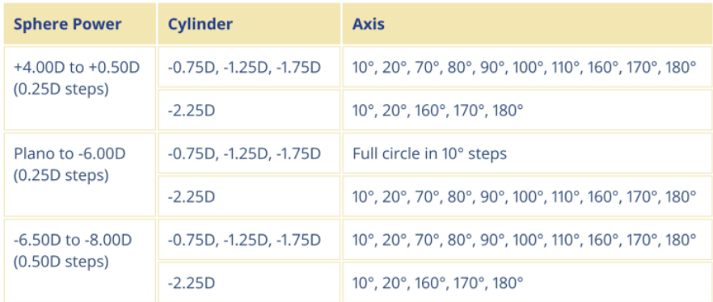
CL script: -3.00/-1.25x170 & -4.25/-0.75x10. Powers below.

- 3rd gen Cooper Vision MyDay Toric dk/t 80 (BC 8.6 DIA 14.5) Sph +8.00 to -10.00, Cyl -0.75DC to -2.25DC, Axis in 10 degs steps.
- J&J Acuvue Oasys 1 Day for Astigmatism dk/t 129 (BC 8.5 DIA 14.3), Sph +4.00 to -9.00, Cyl -0.75 to -2.25DC.
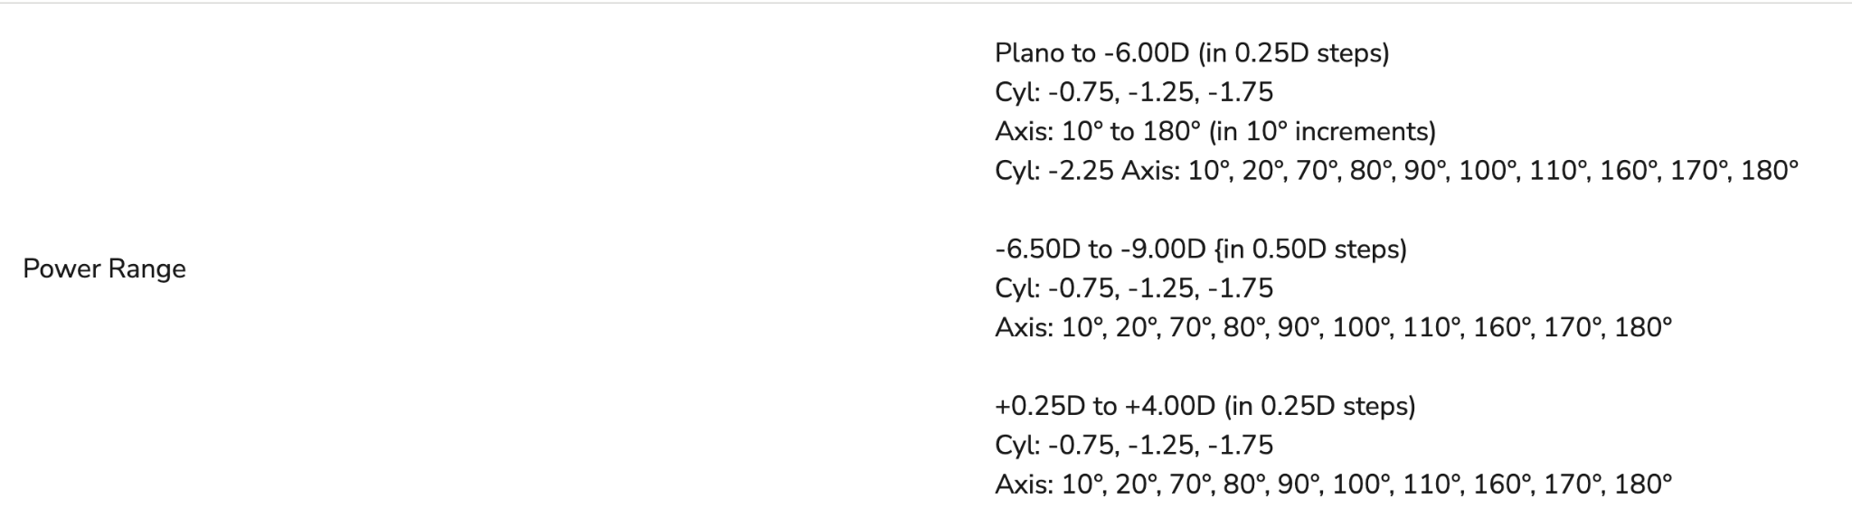
-2.25DC only available for plano to -6.00D. Otherwise, axis restrictions apply the same as for DT1
  - Fortnightlies
- cAir dk/t 110 (BC 8.4 DIA 14.2) Sph +8.00 to -10.00, Cyl -0.75DC to -2.25DC
- 2nd gen Acuvue Oasys for Astigmatism dk/t 129 (BC 8.6 DIA 14.5):
Same as daily ver but also -2.75DC available for -6.50 to -9.00, -0.75 and -1.25 are in 10 deg steps but -1.75,-2.25,-2.75 are limited to 10 20 160 170 180.
  - Monthlies
- 2nd gen SiHy Alcon - Air Optix plus Hydraglyde dk/t 108 (BC 8.7 DIA 14.5): +6 to -6.00 in 0.25 steps, -6.50 to -10 in 0.50 steps. again only available in 0.50 steps up to -2.25, 10step axes. Markings at 3,6,9 oclock. EW 7days
- Alcon - Total30 for astigmatism dk/t 123 (BC 8.6 DIA 14.5), Sph +8.00 to -10.00 with similar stepping as above except +6.5 to +8 in 0.50 step, Cyl -0.75 to -2.25DC
Sph silicone hydrogel core (like other SiHy lenses), it has a unique surface technology that creates a nearly 100% water content outer layer.
- 3rd gen SiHy Coopervision Biofinity Toric dk/t 116 official site says this, but the official site for biofinity toric XR says 0 which makes no sense… (BC 8.7 DIA 14.5) Extended wear up till 7days/6nights. Sph +8.00 to -10.00, Cyl -0.75 to -2.25DC, 10 degs steps
- B&L Ultra (BC 8.6 DIA 14.5 6 oclock orientation mark) dk/t 114 7 days extended wear. +6.00D to -9.00D in 0.25D steps (0.50D steps above -6.00D), -0.75D, -1.25D, -1.75D, -2.25D, -2.75D in 10 degree steps
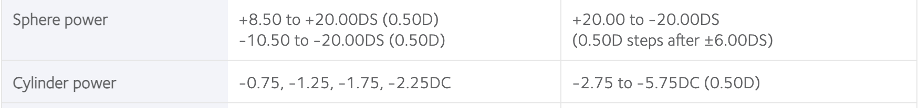
- Coopervision Biofinity TORIC XR BC 8.7 DIA (as above but axis 5 degree steps and cyl up to -5.75DC).Sph +20.00 to -20.00
- What type of contact lens is it? Airoptix hydraglyde = lotrafilcon B, Total1 dailies = Delefilcon A, Myday= stenfilcon A, biofinity = comfilcon A, oasys = senofilcon A, ultra = samfilcon A. All Silicone hydrogel toric lens listed above, they are made of silicone and fluorine polymers with water content.
- What Rx would you give (I said DD so had to change Rx) if the right eye lens rotated to 5 o’clock given the lens marking is at 6 o’clock?
If the lens rotated to 5 o’clock, this is a nasal rotation (i.e. anticlockwise). The lens has rotated 30 degs as each minute of rotation is equivalent to 6 degs. To adjust for this, the axis will need to be adjusted from the spectacle prescription (-3.00/-1.25x168) using the CAAS rule (Anti-clockwise = subtract) Hence the new CLs rx will be -3.00/-1.25x 138 and the lens chosen will have axis 140.

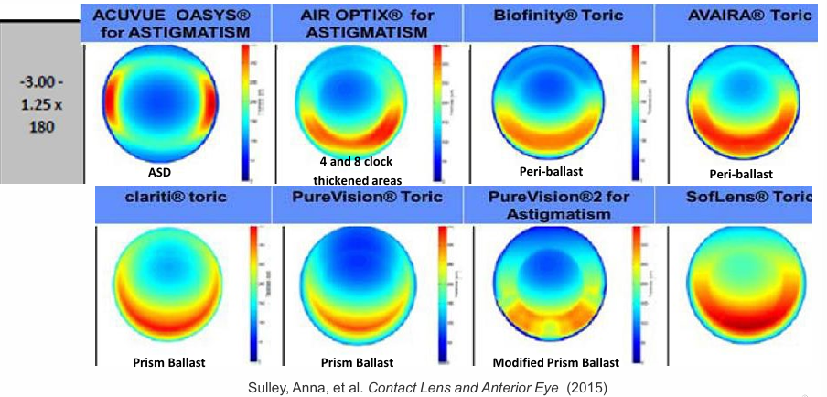
- what determines rotation of a toric lens on eye/stabilisation technique

during blink, eyelid rotates lens to move thicker portion to inferior location. They use peri-ballast where there’s no prism in optic zone, negative lenticulation of peripheral zone, and slab-off of lenticulation in upper portion of lens gives thin upper lens edge. This makes it overall thinner than prism ballast which they use in toric rgp lenses.

There’s also dynamic stabilisation which is a thin zone double slab off, reverse prism. Thinned zones at top and bottom, thicker laterally, lid forces maintain lens orientation to promote comfort, most common form of axis stabilisation. The lens is thickest along the steep meridian of the eye (makes sense). So ATR cyl is good because left and right is steeper meaning the stabilisation fills in the gap, whereas WTR steeper vertically so can have lens rotation due to lid influence, more aggressive orientation system required. Oblique similar idea to with the rule.
- Why may the lens marking not align/rotate? Too tight lens will not respond to lid forces and may clamp on at the inappropriate axis, or a too loose lens may show unstable orientation.
Other reasons include– nasal torque induced by blinking action– angle at which lids meet during blink– orientation of cylinder axis– orientation of thick/thin zones of lens (resulting from cylinder axis, lens design)
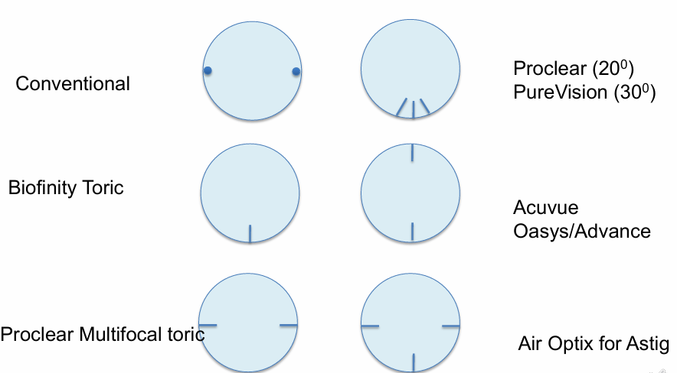
- Range of astigmatic correction?
Toric soft lenses are available in -0.75, -1.25, -1.75, -2.25 cyl
5.75DC is max - Only Cooper Vision Biofinity Toric XR offers that.
Biofinity Toric XR:
- For cyl -2.75 to -5.75DC (0.50DC steps), Sph +20.00 to -20.00 (0.50 steps after +/-6.00D). Axis: 5° to 180° (5° steps)
- For cyl -0.75 to -2.25DC (0.50DC steps), Sph +8.50 to +20.00, -10.50 to -20.00 (0.50 steps). Axis: 5° to 180° (5° steps)

- Why is RGP toric better?
SCL do not offer a significant tear lens that helps mask corneal irregularities, which means even if you prescribe the correct adjusted prescription you may not achieve crisp vision. The soft CL may also not be able to mould to the irregular contour of the cornea, meaning it may fit poorly and fall out.
For FIT reasons – can fit highly astigmatic corneas, customized to individual cornea/patient
For VISION reasons – In high cylinders, visual quality/acuity with RGP torics superior than SCL torics or spectacles
- What are some RGP materials?
Rigid lens material: PMMA – no oxygen permeability; Glass
Rigid GAS PERMEABLE lens material:
- Silicone acrylates (SA) – first generation
  - Dk: up to 30 – low to medium; Problem: surface deposition
- Fluoro-silicone acrylates (FSA) – second generation
  - increased oxygen permeability; increased deposit resistance – but lipid deposition is still a problem
- Super Dk Materials – third generation
  - Further improvements in FSA materials; Dk = 60-100; Boston XO
- Hyper Dk Materials - Menicon Z, Dk=161
- What's an example of a RGP material?
The BOSTON Fluoro Silicone Acrylate with hyperDk material, XO2. Dk 141 so commonly used.
Other types include Boston XO (Dk 100 - super Dk) or Boston EO (Dk 58 - moderate Dk).
- What properties do we look for in RGP? besides Dk and wettability? a. Hardness and durability? Refractive index, UV blocking, edge profile- Want rounded anterior and posterior edge for best comfort, Biocompatibility
- How to measure wettability? Two methods
- Sessile drop technique (water in air): They measure by placing a droplet on the material and measuring the contact angle, the Smaller the contact angle the more wettable the material
- Captive bubble technique (bubble in water): Contact Lens goes into the cell and bubble is created using fine Needle. As air bubble is released, it floats and touches CL surface. Contact angle measured based on how It touches the surface. That gives you contact angle
- What parameters of RGP are there? a. Monocurve vs tricurve, lens diameter, intermediate or peripheral curve curvatures and widths, BOZR, BVP, material
- Would you fit a monocurve or tricurve lens? a. Tricurve since the cornea becomes flatter in the periphery
- Would the values for tricurve go up or down? a. Flatter = higher values
- How do you determine LD?
- Smaller than HVID, interpalpebral distance
- BOZD needs to be larger than pupil size. Typically a 11mm eye requires around a 9.2mm lens diameter. Adjust in 0.2mm increments as the HVID increases or decreases by 0.5mm (but keep in mind that 11.5 is still a 9.2mm Diameter). If interpalpebral distance is >11 then you can do a 9.6 and decrease as the distance gets smaller.
- How do you measure pupil size a. Slit lamp, adjust light width and measure under low illumination using a ruler or by comparing the size of the pupil to the light width/height.
- Complications of RGP? a. 3 and 9 o’clock staining, dellen, VLK (EXCLUSIVE TO RGP CLs wear; ring of dilated blood vessels that extend from limbus to cornea), lens adherence, dimple veiling from too steep, fischer schweitzer mosaic from too flat.
- What is the exact cause of 3 and 9 o’clock staining?
Definition: Desiccation of cornea outside of lens edge
CAUSES
- Too much edge lift = thirsty tear meniscus (thirsty tear meniscus sucks out tears from just outside lens edge of the lens causing drying)
- Too little edge lift = minimal tear reservoir
- Bridging effect at lens edge = eyelid can’t resurface cornea with mucus, occurs if lens edge is thick and sits away from corneal surface.
- All 3 situations are exacerbated if inadequate/incomplete blinking
Natural history: punctate staining → coalescent staining → dellen formation → peripheral ulceration → vascularised limbal keratitis (VLK)
- Does RGP give better vision than SCL for toric lenses → how about specific to BST?
- RGPs have an advantage over SCLs as the tear layer between the lens and cornea has astigmatism power, so they can correct corneal astigmatism. SCLs torics have cyl power built into the lens to correct refractive astigmatism regardless of amount of corneal astigmatism.
- RGP better than SCLs for high cyls.
- Rotation of SCL torics can change astigmatism correction while rotation of SPHERICAL RGPs won’t since the amount of correction is the same.
- Upon blinking any small deviation of SCL will cause unpleasant vision discomfort.
BST RGPs are better fitting on highly astigmatic corneas (corneal astigmatism needs to be graeter than -2.00DC) BST design has a toric back surface which is able to adhere to the irregular corneal shape so there is better fit between the lens and cornea..This avoids lens rocking on the cornea and better visual stability. SCL may not be able to mold to the corneal shape if it is extremely irregular.
- When do you use PMMA?
PMMA is used when you are trialling the patient in the office. Good for trial set kits as they last long and do not require to be stored in solution (i'm just writing this like how we used to store them in labs). Would not dispense this as they are oxygen impermeable causing corneal hypoxia and corneal oedema.
- If the monthly CLs are contaminated with acanthamoeba, does Optifree pure moist completely get rid of it? No it doesn’t eliminate it. Acanthamoeba exists in two forms (trophozoite - active, cyst - dormant) in which the cyst form is highly resistant
to disinfectants like Optifree Pure moist MPS. MPS also doesn’t have enough contact time to kill the cyst effectively. Many studies suggest heat is only effective method to kill cyst (10 mins at 80 degs, CLs soaked in saline) Some controversy about efficacy of hydrogen peroxide (even 72hr soak may not kill cyst), surfactant clean (rub and rinse) may provide effective 1st line defense esp alcohol based cleaners such as Miraflow which helps splits cyst apart
Acanthamoeba is a free living amoeba found in most soil and water habitats- life cycle of a feeding and dividing trophozoite.
Moisture Plus MPS caused outbreak of AK in 2007 in USA. removed from market but incidence of AK still elevated suggesting possible rise in number of Acanthamoeba in the environment.
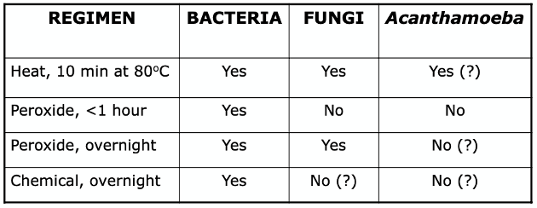
- Convert the spec script-3.00/-1.25x168 and-4.25/-1.00x10 and suggest a CL brand
After VD correction (14mm): -3.00/-1.00x168 and -4.00/-1.00x10
CLs script: -3.00/-0.75x170 and -4.00/-0.75x10
CLs brand: Alcon DT1 for Astigmatism dk/t 127, +4 to -8 (DD), Acuvue Oasys dk/t 129, +6 to -9 (Fortnightly), Total 30 dk/t 123, +8 to -10 dk/t (Monthly)
- In a regular high cyl px, which is better: SCL or RGP?
SCL better if unable to tolerate RGP
RGP better if there is low spherical component but high cyl (e.g. -0.50/-2.00x180), axis is oblique as less success with SCL, want superior visual quality/acuity, want personalized/customized fit.
RGP lens type | Prescription and Corneal K indications
Spherical | - Low corneal astig: theoretically up to 3.00DC, but <2.00DC is usually the upper limit  - Low refractive astig
Front surface toric | - Low corneal astig but high refractive astig  - SCL toric is better
Back surface toric | - High corneal astig at least 2DC  - Refractive astig 20-40% higher than corneal astig
Bitoric - Spherical power effect (SPE) | - High corneal astig at least 2DC  - Refractive astig = Corneal astig
Bitoric - Cylindrical power effect (CPE) | - High corneal astig at least 2DC  - Refractive astig NOT equal to Corneal astig
- What would you tell a px who wants to swim with CLs
RIGID LENS: easily lost from the eye,
- Please wear goggles while swimming. Close eyes/ protective squint if diving.
- Ideally wear DDs. Discard/disinfect lenses after removal. Lens can be contaminated due to swimming pool water (chlorine and non physiological tonicity and pH) causing ocular irritation, oedema, epithelial cell damage, risk of other contaminants such as bacteria and acanthamoeba.
- DON’T remove lenses immediately as the surface tension between water atmosphere and eye can cause the lens to adhere tighter to the eye. It is possible that corneal epithelium can be ripped off. Irrigate lenses on the eye with saline before removing to alleviate tension between the lens and eye and wait a short while to ensure the lenses can be moved freely before removal. Alternatively, wait 15-20 mins before lens removal.
- Why does lens get stuck on eyes after swimming? Exposure to hypotonic (pool) water. OSMOTIC PRESSURE causes the moisture from lens to dry out, making it suck to the cornea.
- Do you expect a rotation on toric lenses naturally → How much rotation do you expect? If you do, how do you compensate?
Yes, you may expect some natural nasal rotation of around 5-10 degrees because of natural blinking forces, especially from the lower lid which cause the lens to move vertically and rotate nasally. Use the LARS rule to compensate.
- Sometimes rotation is good. e.g. RE Rx -1.00/-0.75x5, CL Rx is -1.00/-0.75x180, the lens with 180 axis with 5 degree rotation to the nasal/right is equivalent to fitting a lens with axis 5 (not available for eg total30, airoptix, or any DD), which is perfect for this case, no adjustment needed
- You may also see that a natural 15 degrees nasal rotation is seen for FST RGPs (lecture notes); so compensate for this in the initial order to minimise reordering and more money spent.
- What position would you expect the lens marking to be
  - Cooper Vision Biofinity: 6 o’clock
  - Cooper Vision Myday toric: 6 o’clock
  - Alcon Totals Range: 6 o’clock
  - B&L Ultra and Purevision: 6 oclock
  - J&J Acuvue Oasys fortnight: 6 and 12 o’clock
  - Alcon Air Optix with hydraglyde: 3, 6, 9 o’clock
  - Alcon Aqua Comfort plus: 3 and 9 o’clock

- Person with -5.00 DC, what RGP lens would you recommend?
A toric RGP must be given as this is a high refractive cyl. Spherical RGP only with low refractive astigmatism. The type of toric RGP depends on their corneal cyl. If the corneal cyl is lower than 2D a FST could be prescribed (for most part can use SCL toric instead). If at least 2D corneal cyl, bitoric may be the most ideal. SPE bitoric if refractive astig ~ corneal astig, CPE bitoric if refractive not equal to corneal astig. BST only if refractive 1.2-1.4x corneal cyl.
- What complications are there with sleeping in CLs? & Minimum requirement of avoiding hypoxia in CL wear
Corneal hypoxia, corneal odema, CLARE, CLPU, MK
Around 3-4% corneal oedema common during normal eye closure overnight. To prevent central corneal swelling and for oedema to be the same if no CLs are worn, overnight CLs wear by holden and mertz criteria is minimum dk/t = 87 (revised material by harvitt and bonanno says 125) and daily CLs wear minimum dk/t = 24 (revised is 35). To prevent peripheral corneal swelling in DW, dk/t =33. To prevent limbal hyperaemia, min dk/t = 55. Ideally dk/t = 125 x 10-9.
Overnight 87 → 125
Daily 24 → 35
- Signs of hypoxia: Endothelial signs and then she asked what are the complications/effects you might be worried about with endo hypoxia or smth?
- Corneal Epithelium: Microcysts (accumulation of cellular debris or necrotic material from altered metabolism in hypoxia), Vacuoles (smaller than microcysts, unreversed illumination). Why is it bad? Corneal Epithelium thins over time ~15% if long term hypoxia. Short term not much change. May also get basal cell irregularity.
- Corneal Stroma: generalised haze due to loss of ordering collagen fibrils in cornea. Swelling/oedema (striae, folds) - due to byproducts of anaerobic metabolism (lactic acid) accumulating in stroma. Increased anaerobic metabolism, alters osmotic gradient.
- Corneal Endothelium: blebs (due to anaerobic metabolism), polymegathism/pleomorphism (increased acidification of stroma causing cellular changes in endothelial cells)
- Limbal hyperaemia (most along horizontal meridian due to exposure) → corneal vascularisation
  - Hypoxia induces inflammatory responses by producing VEGF and other cytokines, promoting growth of new vessel into the avascular cornea
- Others like CTT, corneal warpage, corneal exhaustion syndrome.
- How would you see the microcysts? a. Reverse illumination b. What is that? You shine the light from one side of the microcyst and you see the feature highlighted on the opposite side of the illumination (dullness on same side). Unreversed is opposite where the feature is highlighted on the same side of the illumination.
- How would you manage the microcysts? a. Refit to higher dk/t and reduce wear time
- What do you expect the microcysts to do after refitting to higher Dk/t / reducing wear time? a. Initially increase for about 1wk and then decrease over 1-3 months
- Would the patient get any symptoms from the microcysts? a. Generally asymptomatic, but some may have mild irritation/ transient hazing of vision
- Why are complications with the endothelium bad? a. Endothelium is a one cell layer that doesn’t regenerate like the epithelium. Loss of corneal endothelial cells would affect the endothelial pump
Changes in endothelial cell morphology can result in a loss of function in endothelial cells → affect endothelial pump in which fluid won’t be able to be pumped out of the stroma through the endothelium into the AC → excess fluid in stroma→ impacts ability to maintain clear cornea → hazy vision and visual distrubances
- Stromal striae and folds She asked which one do you see first and how much edema Striae first at 5% and folds at 8%
- How do you treat polymegathism (variation cell size) and do you expect it to change? Increase dk/t and stop EW it would stay the same- doesnt improve because you have asdalready induced the change to the endothelium.
- Possible complications of RGP lenses?
- Inappropriate fit (too steep or too flat)
  - Too steep → Dimple veiling, mucus and debris (central seal off),
  - Too flat → Fischer Schweitzer corneal mosaic
- Adherent RGP lens and corneal indentation (transient)
- 3 and 9 o’clock staining
- Rigid lens edge abrasion on insertion and removal
- Entrapped FBs
- corneal metabolism is impacted due to hypoxia.
- Why is Boston XO commonly prescribed? high Dk, less issues with deposits and wettability
- Which one is safer? Rigid lenses or soft lenses, what about Ortho-K lenses? RGP lenses are generally the safer option out of the two because it has less deposit buildup, has better tear exchange, less chance of complications including CLPC and SEAL ? Ortho K is a reverse geometry lens design which has good Dk and is approved for overnight use. As it is not worn during the day, a typical wear time of 6-8 hours minimises the chance of complications compared to if you had an EW rigid or scl.
- How is toric RGP stabilised? 1-2BD prism ballast to stabilise. Only FST needs a prism ballast.
- MF options in CL Then she said is RGP an option
  - Cooper Vision MyDay (BC: 8.4 DIA 14.2) - Daily, +8 to -12 dk/t 100,
  - Alcon Dailies Total 1 (BC 8.5 DIA 14.1) - Daily, +6 to -10 dk/t156
  - Alcon dailies aquacomfort plus (BC 8.5 DIA 14.1) daily
  - Alcon air optix plus hydraglyde multi (BC 8.6 DIA 14.2) monthly
  - Alcon total30 Multifocal (BC 8.4 DIA 14.2) - Monthly, +6 to -10 dk/t 154
  - Biofinity N D centre multifocal (BC 8.6 DIA 14.0) - Monthly, +6 to -10 dk/t 142
  - Biofinity toric multi N D (BC 8.7 DIA 14.5) - Cyl up to 5.75, 5 deg steps, -10 to +10, dk/t 142
  - Biofinity proclear XR (BC 8.7 DIA 14.4) THIS IS HYDROGEL SPHERE
  - RGP is an option too, such as capricornia RGP SA Multifocal, multifocal toric, eyespace bespoke multifocal.
- How would you choose between the different types
  - Depending on occupation/hobbies, and high cyl + others, patient personality type, first time wearer, hygiene.
- Elaborate on how hobbies/occupations affects my choice if the patient works in an office with air conditioning environment they may be more suitable for RGPs because the air conditioning can dry out SCLs and induce dry eye symptoms. Any workplace with a dusty and debris prone environment would also suit RGPs more due to lack of tear exchange and flush out of debris for SCLs. If they require sharp vision for their job then RGP may be more suitable (for high cyl patients). If they are involved in sports or water activities SCL are better as an RGP may get dislodged with high impact activities due to small diameter.
- Then she asked about high cyl and how that would affect my choice RGP would be more suitable for a high cyl due to the likelihood of having corneal cyl which is also high. SCL may rock and not mould to corneal shape if high cornea cyl.
- Asked to give an example of soft CL toric multifocal biofinity toric multifocal
- Convert this rx: +4.00/-1.00x120, +3.00/-2.00x10.
Conversion should be +4.25/-1.25x120 and while no correction is needed for the left eye, -2.00 is not available as cyl powers
CL Rx: +4.25/-1.25x120, +3.00/-1.75x10.
Keep in mind that dailies aquacomfort plus, total1dk/t 127 and acuvue oasys DD dk/t 129 do not have +4.25. Have to use myday if you want daily
Use
- MyDay (Daily) 8.6/14.5 +8 to -10 dk/t 80
- cAIR (Forthnightly): 8.4/14.2 +8 to -10 dk/t 110
- Total 30 (Monthly): 8.6/14.5 +8 to -10 dk/t 123
- CV Biofinity (Monthly) : 8.7/14.5 dk/t 116
All these come in +8.00 to -10.00 (axis 10 degs steps around the clock)
- What if the px really wants to sleep in them Have to warn them about the possible complications from sleeping in lenses.Recommend an EW but i would really tell them not to closed eye state is a very easy way for microbial load to cause inflammation because the bacteria release endotoxins during sleep.
- What EW would you prescribe for this px Air optix night and day for spherical (30 nights) but if toric then has to be biofinity for astigmatism XR range if greater than 2.25. Also emphasise it is only 6 nights/7 days so px can’t sleep in it for more than that per month. CANNOT REINSTATE ANOTHER ROUND OF EW IN THE SAME MONTHLY LENS.
Air Optix Night and Day can be used for EW for 30 nights OR used as a monthly lens
AIR OPTIX plus HYDRAGLYDE can be used for EW for 6 nights OR used as a monthly lens
- What is an RGP MF design? How does it work?
4 types of designs - Concentric, Aspheric, Alternating/Translating, Simultaneous Vision
https://www.reviewofcontactlenses.com/article/gp-multifocal-contact-lenses-the-2024-lineup
- Concentric (like SCL MF i think?)
  - Concentric rings of varying power - typical centre dist zone with, surrounding rings for near and intermediate vision (can be vice versa)
  - Allows for simultaneous viewing of multiple focal points, brain learns to choose more appropriate focal point depending on visual task
  - Relies on pupil size and lighting
- Aspheric
  - Gradual change in curvature from centre to edge of lens resulting in gradual plus power towards periphery
  - Smooth transition between dist, intermediate and near vision minimises image distortion and improve depth perception
  - Centre dist design → maximises dist and intermediate vision
- Alternating/Translating
  - Similar to BIF glasses, with seg in lower part of lens for near vision
  - Lenses are prism ballasted to rotate near zone towards the bottom
  - Design to stay in place when px looks down so can switch focus fr dist to near with normal eye movements.
- Simultaneous Vision/ EDOF?
  - Have multiple back optic zones (dist, int, near) at same time. I.e. Both Dist and near powers in front of pupil simultaneously.
  - Brain selectively processes image from correct focal point
  - Requires more adaptation - brain needs to learn to filter out non target imaging e.g. ignoring near vision when focusing on dist objects
Aspheric multifocal gradually change curvature along the anterior or posterior surface of the lens, resulting in plus power toward the periphery. Due to their center-distance design, these lenses maximize distance and intermediate vision; requires minimal interaction between the lens and the lower eyelid, allowing patients who have loose or low-riding lower eyelids to benefit from the add power. multiple optical zones for different distances are present on the lens at the same time. Light from both near and far points enters the eye, and the brain learns to interpret the correct focus depending on the visual task. translating bifocals/trifocals is a different type of MF design which consists of a distance zone and a near add segment, much like a bifocal spectacle lens. The lenses are prism ballasted to rotate the near zone toward the bottom when placed on the cornea. They utilize the lower eyelid to push the lens superiorly during downgaze to place the add zone in front of the pupil. The add segments come in different designs, much like their spectacle counterparts: executive, crescent, and concentric.
- How does centre-distance and centre-near work? Use the cooper vision multifocal fitting guidelines for centre-distance and centre-near. Normally the MF designs are made so that there is a centre-near zone because when we read the pupils tend to constrict. By constricting, the peripheral rx will be cut out allowing a comfortable near experience. D centre is also an option but only biofinity has this where the dominant eye is given the D centre to simulate a modified monovision design. D centre is also a popular design chosen for potential myopia control as peripheral myopic defocus is theorised to slow down axial length progression.
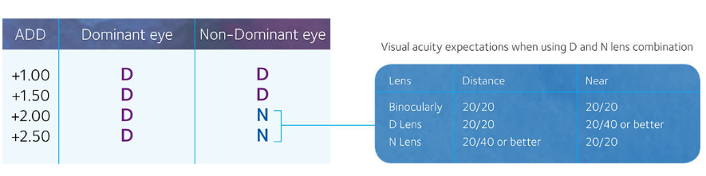
- How do you determine sensory dominance? BCVA for D and N, aided, do 1 or 2 lines above, place +1.50 or +2.00 lens over each eye for a few seconds and ask px to observe binocularly which one has WORSE vision, this is the DOMINANT eye. Repeat 3 times to confirm the right one.
- Sight dominance = With both eyes open, hold your hand at a comfortable distance and form a triangular shape. Through the aperture, look. through to see a small but visible letter or object at around 6m. And then we occlude either eye and see which is the one that continues to see the letters when the other is being covered
Patient wears their current specs/glasses. Instruct your patient to look through the triangle made by thumb and forefingers of both hands while extending their arms. To begin with, the patient looks at a distance target through the triangle using both eyes. Then they close each eye to view the same target, the eye with which the object stays centred in the triangle is the DOMINANT eye. Repeat the test three times.
- What to do if the dominant eye is the same at D and N? Not suitable for monovision as it works best when swapping dominance at distance and near. Dominance can also change so if the first fitting is not successful with the px you can attempt to swap the eyes for dom vs non dom and then see if that makes any difference. If still not, then means unsuccessful.
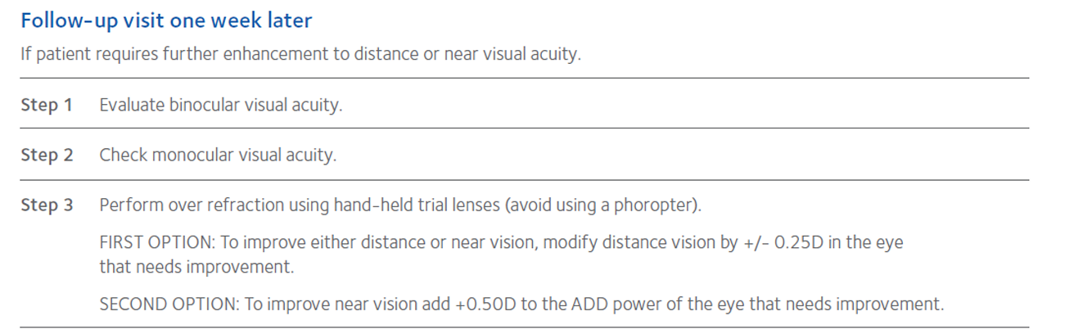
- Considerations for presbyopic CL;
- MAXIMISE PLUS AT DIST to help near vision.
- Choose LOWER ADD if unsure - easier adaptation and minimise haloes for MF, minimise differences between the eyes for MONOVISION
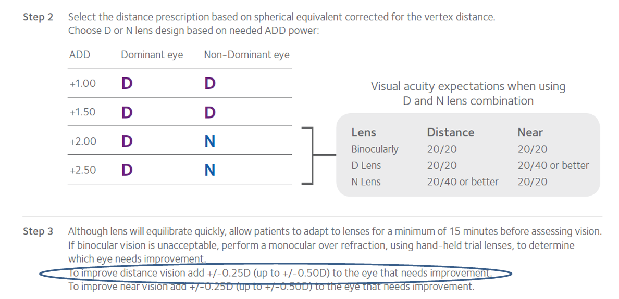
- Follow manufacturer’s fitting guide. E.g., for Coopervision Biofinity fitting guide, see above
- Over rx should be done binocularly with no occlusion as px relies on binocular vision to see far and near.
- Potential difficulties with driving.
- How does pupil size affect your decision between MF and monovision?
- Px needs a pupil that can dilate under normal lighting conditions to see through the distance portion of the lens and one that can constrict so that it looks through the centre near portion (for a centre near lens).
- If the natural pupil is too small that may mean they look through the near portion even when viewing far objects which will affect their visual comfort. In these cases, monovision may be preferred.
- How do you expect this final lens to look on the eye? Should be well centred, full limbal coverage, toric lens marking 6 oclock but may get some nasal rotation due to natural nasal torque of eye.
- What brand of CLs would you consider for this patient? Biofinity toric mf is the only MF that offers cyl correction.
- What if this patient said they wanted to wear lenses while sleeping and what kind of concerns are associated with this? Corneal hypoxia, clare, clpu.
- What options would you consider for a presbyope wanting to wear contact lenses? MF CLs, Monovision CLs, SVD CLs with overspecs reading
- Does a RGP multifocal work the same way as a soft contact lens multifocal? Most soft multifocal lenses use concentric ring designs or aspheric surfaces with a gradual power shift from distance to near. Soft MF CL create multiple images through the pupils, allowing the visual system to decide which one to focus on depending on the task. Therefore, the pupil size must be sufficient enough to be able to see through all zones of the CL or the px won’t get the benefit of the MF design.
On the other hand, RGP lenses have multiple back optic zones (dist, int and near) at the same time for simultaneous vision design. The eye and brain work together to interpret the correct focal point based on what the wearer is looking at. If it is the alternating/translating design they have separate areas for dist and near and relies on movement of eyes for appropriate zone to cover pupil for dist and near.
- Considerations of MF CLs vs Monovision CLs
- Monovision
  - Advantage: Use SV lenses, simple and easy to adjust, cheaper, easier to understand, less chair time, greater flexibility, better for astig
  - Disadvantage: Binocularity compromised (stereopsis may be a problem) as one eye not corrected for best dist vision,, May be harder to adjust to if px add is high (works better with lower add), not everyone can tolerate the difference in rx and doesnt work if px only has one eye, may also require additional correction such as over specs because the add in CL must not be too high in that it will cause blurry vision at D affecting px viewing experience.
  - Ideal candidates: 1) require lower adds; 2) need astig with presbyopic correction; 3) swap dominance between D and N
- Multifocals
  - Advantage: provide binocularity allowing for depth perception
  - Disadvantage: Vision compromised - haloes, glare in vision and reduce contrast sensitivity, no toric options except for biofinity toric MF
  - Ideal candidates: 1) low cyl; 2) understands that vision is not always sharp; 3) unable to adapt monovision; 3) wants stereopsis
- What lens would you recommend for this px?
Spherical:
- Daily - DT1 8.5/14.1, +6.00 to -10.00 or MyDay 8.4/14.2 +8 to -12
- Fortnightly - Acuvue Oasys MF with pupil optimised design 8.4/14.3, +6.00 to -9.00
- Monthly - Biofinity 8.6/14.0 +6.00 to -10.00 or Total30 8.4/14.2 +6 to -10
Toric:
- Biofinity Toric MF (Monthly) - 8.7/14.5 +10.00 to -10.00, Cyl up to -5.75DC
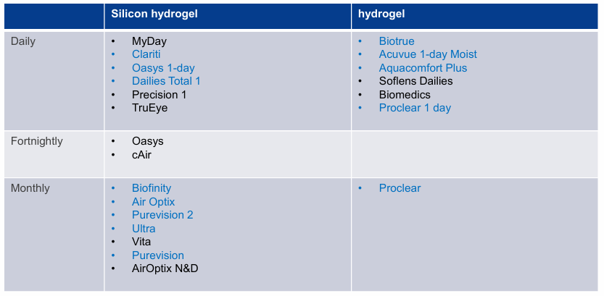

Blue ones are all available in multifocal, only Proclear and Biofinity have the option of centre D/N. Only biofinity has toric, PROCLEAR DOES *****NOT***** HAVE TORIC
B+L Ultra for presbyopia, biofinity toric MF, airoptix with hydraglyde have extended wear up to 7 days/6 nights.
- Lens rotates 10 degrees nasal, what would you do with this rotation information? LARS (Left Add Right Subtract) rule would apply here, if rotating 10 degrees nasal in RE then lens moves RIGHT so SUBTRACT 10 degrees, if rotating 10 degrees nasal in LE then lens moves LEFT so ADD 10 degrees sleep
- What would the lens orientation be on the eye? Lens will still be oriented 10 degrees nasal so any marking would show a 10 degree rotation, however, we already would have accounted for it with their true spectacle axis being in front of the eye
- What if px wants to sleep in the CLs? What concerns do you have for the px sleeping in the lenses? Stress the importance of sleep avoidance in CLs due to increase risk of infection, increased hypoxia, increased debris build up behind CLs, RESOUNDING NO
- If the px really wants to sleep in the CLs, what CLs would you recommend?
Air Optix plus Hydraglyde (approved EW for 6 nights) - comes in toric, sphere and multifocal sphere types
Air Optix Night and Day (approved EW for 30 nights) - only comes in sphere type. Biofinity/Biofinity XR (approved EW for 7days/6 nights) - comes in sphere, toric and multifocal sphere/toric types
- Which extended CL is better for this px? Toric patient with high cyl and needs MF will need the biofinity toric MF
- Lets say the patient is 44 what lens do you give then We assume their add is around +1.00 according to age norms. I would recommend a +1.00 add for the biofinity lens as this is the lowest add. See how px adjusts to it. For biofinity MF guide a +1.00 add requires a centre distance with 1.00 add in both dominant and non dominant eye.
- What solutions would you give for a monthly lens and why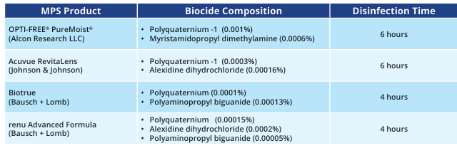 Opti-free puremoist because it is shown to have better disinfection towards more microorganisms including the trophozoite form of acanthamoeba. Also contains dual disinfecting system, polyquad 0.001% and aldox 0.0006%, aldox shown to have some antiamoebic function only against trophozoite form (has to soak for at least 6hrs) However, it is important to note that studies have shown that while it is the most effective MPS for acanthamoeba trophozoites it does not eliminate it.
- What ingredient in Opti-free was researched to have good coverage against Acanthamoeba keratitis? Aldox (myristamidopropyl dimethylamine) reported to have antiamoebic and antifungal activity. However only in its trophozoite form and only if exposed to it for at least 6hrs. Polyquad preservative shown to predominantly have antibacterial activity.
- What are the benefits of hydrogen peroxides and why did you not choose it? Hydrogen peroxide has been shown to have better effectiveness for acanthamoeba trophozoite form. However, effectiveness against the more resistant cyst form of Acanthamoeba is variable and may not be fully guaranteed. As there is a minimum 6 hour neutralisation for aosept before the lens can be worn, a patient may prefer a MPS solution which although instructed to soak in solution for at least 6 hours as well, would not induce toxic reaction if inserted to eye before the 6 hour mark. Opti-free also has hydraglyde moisture matrix which helps keep lenses moist up to 16 hours. MPS many people like it for its convenience. However, AOsept is PF, more effective and less risk of solution sensitivities.
AOSEPT – hydrogen peroxides: PF, no need to rub, maybe better compliance
- Which solutions have multiple disinfecting agents in them?
Optifree, Biotrue MPS, Acuvue Revitalens, Boston Simplus
- Proclear vs biofinity proclear is a hydrogel lens, biofinity silicone hydrogel meaning it has higher dk/t and hence will induce less corneal swelling in EW.
- How do you determine if a patient is suitable for EW?
Conduct thorough H&S
- ensure that px is not immunocompromised or on systemic steroids (dampened immune systems increase risk of infection)
- no regular water sports/activities
- no issues with normal daily wear
- no diabetes (reduced corneal sensitivity threshold, diabetics may be more susceptible to unstable adherence of epithelium to basement membrane; could be increased if corneal hypoxia from CL).
- What would you tell them then?
Lens care, maintenance, avoid water contact/sport, higher risk of infection, signs and symptoms to be aware of so that they can return when they notice them
- When would you review for EW? For the first time wearer of EW, I would review them at day 2 to observe corneal odema and other signs of hypoxia- then at day 7. Then 2 week mark, month 1 then month 3 then 6 monthly. Always RTC earlier if problems.
Aftercare visits recommendations: for normal CL wearer soft or rigid: 2 weeks, 1 month, 3 months, 6 months after delivery, then 6 monthly intervals thereafter.
Aftercare visit: Always perform fluorescein assessment and lid eversion
- Is near sensory dominance tested with best distance Rx or near Rx?
Should be done with near Rx because this simulates which eye is used more during close vision tasks. Using the near Rx ensures that the visual demands and accommodations are appropriate for the task being assessed. Distance Rx would also be blurry up close anyways which means you will already be inducing blur in both eyes so the patient won’t be able to appreciate which is worse.
- What properties would you usually be looking for in an RGP material?
Oxygen permeability Dk (not transmissibility Dk/t), material stability and durability (hardness), wettability, friction indices, refractive indices
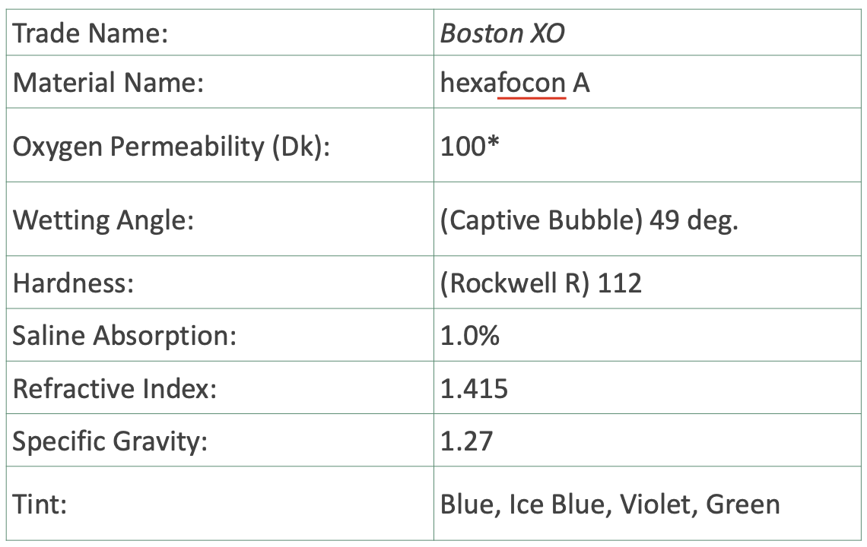
- When talking about hypoxia: Are endothelial blebs permanent or temporary?
Temporary, they are transiently seen immediately (maximal at 25-30mins) after inserting low dk/t lenses. They gradually fade away as CLs wear continues past 2hrs. However if removed at peak of bleb response, mosaic returns to normal within mins.
Seen as dark areas within the endothelial mosaic and are associated with acidification in posterior stromal regions due to anaerobic metabolism and appear as dark black regions like gaps.
- Why are you worried about endothelial polymegathism/pleomorphism?
This is a permanent change → loss of endothelial cell function and failure of endothelial pump. Can be age-related as well
- Which part of the cornea is most likely to be hypoxic?
Central cornea because the lens tends to be the thickest in the central part. Oxygen demand is also the highest in the centre due to active metabolism.
- How is the Dk/t of a lens determined?
Measures the oxygen flux through the centre of the lens based on-3.00D prescription of the particular lens
- List some different types of silicone hydrogel contact lenses
- CooperVision Myday
- CooperVision Biofinity
- Air optix night and day
- Alcon DT1
- J&J Acuvue Oasys
- Complications specific to silicone hydrogel contact lenses
- CLPC
  - Mechanical trauma - Protein deposits on the lens front surface forms a rough front CL surface, SiH usually induce localised CLPC (SiH stiffer than hydrogel)
  - Hypersensitivity response
    - Usually delayed response triggered by protein deposits → they denature and stick onto CLs front surface → recognised as FB → hypersensitivity reaction
- SEAL
  - More common in SiH as they are stiffer than traditional hydrogels. Caused by inadequate lens flexure or high modulus causing mechanical friction or trauma. Thick lens edge can also dig into the superior cornea by pressure of the tight upper lid causing a split in the epithelium that can be as deep to the basement membrane causing stromal glow.
- Soft lens edge indentation (lens too tight)
- Lens fluting (lens too loose)
- Superior limbic keratoconjunctivitis- likely due to chemical toxicity and/or preserved saline. V shaped wedge, irritation, discomfort, cl intolerance, fb sensation. resembles Theodore’s SLK– much less severe– less palpebral conjunctival involvement– filamentary keratitis rare– different demographic pattern (young female soft contact lens wearers). avoid thimerosal in lens care products, or move to non preserved system e.g. H2O2
- Is MK more common in silicone hydrogel vs hydrogels?
Inconclusive in terms of whether there is any change in the risk with Hydrogel vs SiH. Most have shown that the incidence are fairly equal for EW. DDs have lower rate of more severe disease (central, large peripheral, culture proven or when BCVA reduced) than other DW or EW MK but have not been proven to be ASSOCIATED WITH LOWER RISK of MK than DW reusable CLs. Daily disposable lenses: does not decrease absolute risk of contact lens infection, but do result in less severe disease and fewer cases of vision loss as compared with frequent replacement soft CL
- Risk factors for MK? Any overnight wear, increased duration of overnight wear, contact with tap water, case hygiene, not handwashing prior to CL handling, smoking,infrequent disinfection/topping off, lens type other than RGP, Solution type (Complete/Renu)
- Cause of SEAL? Inadequate lens flexure or high modulus, resulting in mechanical friction or trauma between the superior cornea and the lens and when combined with eyelid forces squeezs the post lens tear film (often due to the action of the superior lid) → switch to lower modulus lens (Would not switch to hydrogel lens bc dont want hypoxia to be increased).
- Name lenses with higher modulus
Higher modulus = stiffer
Modulus is the ability of the material to resist deformation under tension
- Air Optix Night and Day Aqua (SiH Spherical Monthlies) - Modulus 1.5MPa
- PureVision 2 (SiH Monthly) - Modulus 1.1 MPa
- Air Optix Plus Hydraglyde - Modulus 1.0 MPa
- Dailies Aqua Comfort Plus (Hydrogel Toric DDs) - Modulus 0.9MPa
- Biofinity - Modulus 0.75MPs
- Acuvue Oasys 1Day (SiH Spherical DDs) - Modulus 0.72MPa
- Are most contact lenses prescribed today silicone hydrogel or hydrogel? Why?
Most are SiH because their high oxygen permeability so minimising risk of corneal hypoxia which can cause corneal swelling and abnormal BV growth on cornea. SiH are easier to handle esp for 1st time CLs wearers due to relatively higher modulus of elasticity (i.e. more stiffer and less likely to deform). SiH also have a lower water content so less likely for dry eye compared to Hydrogel which have HWC which will lose moisture more easily to the environment and absorb water from the tears. Keep in mind that ionic materials deposit more and denature more protein.
- R +6.00/-2.00X12, L +5.00/-4.00X10.
After vertex distance correction, R +6.50/-2.25x12 L +5.25/-4.25x10
Prescribe: R +6.50/-2.25x10 L +5.25/-4.25x10
- What contact lens is suitable for that script?
Biofinity Toric for RE and Biofinity toric XR for LE. BC 8.7 DIA 14.5
- What if the lens was rotated to 5 o'clock in the right eye?(Q86)
Use LARS rule: +6.00/-2.00x162 → New CLs script +6.00/-2.00x160
- Where would you expect the toric marking to be?
She asked but if its rotated 30 degrees, do you think it would still rotate that much. I said possibly not if the change cyl axis of the lens changes where it orientates. - so 5-15 degrees nasally?
- Contact lens wearer in competitive sports and needs eyes open in water sports, what do you tell them
- Scripted goggles (no CL)
- DD with tight fitting goggles
  - Chuck out CL after swimming and pop in a fresh new pair
- Monthlies: After sport, clean them after removing the lenses with MPS or H202 or get px to get dailies for when they do sports if occasional
- Wait 15-20 min before removal or irrigate eyes with saline then wait a few minutes before taking off
  - There is a possibly of ripping the corneal epithlium off due to the exposure to hypotonic water.
- CLs wearer who wants to go camping and hiking. What sort of lenses would you recommend?
Initially said daily disposables if they have access to clean water and soap
No clean water accessible - EW instead as they would not need to touch the contact lenses directly during the camping trip
- Why would you not want to prescribe EW for general use? Increase risk of MK, hypoxia, CLARE, CLPU. Although CL have been approved for EW wear such as Air Optix night and day, biofinity, and BL ultra, the studies that were used to get them approved do not represent the real life expectations. Patient adherence, demographic, lifestyle habits may all be very different to what they test in studies. Trials are not indicative of how real practice is as they often use the best scenario conditions. E.g., may have used a new lens, may have used a new storage case, rub and rinse was conducted to the full amount.
- Any extra precautions you would take when prescribing extended wear
- Check for any use of corticosteroids (systemic or topical)
- Dry eyes (hormone replacement therapy, birth control, antidepressant etc..)
- Systemic condition (Sjogren or immunocompromised?)
- Patient hygiene
- Occupation (maybe not so good if they are in construction or working in dusty/polluted environments)
- Why do we want full limbal coverage?
- Ensure no corneal desiccation of exposed region
- Reduce mechanical stress of the peripheral cornea
- Dont want edge of lens to cause mechanical trauma on cornea/ limbus (limbal stem cells)
- Constant rubbing of lens on limbus may induce unwanted complications such as limbal stem cell deficiency
- Why do we want lens movement? a. To allow for tear exchange and reduce hypoxic effects, no movement can result in lens debris to be trapped underneath the lens and include inflammatory complications?
- What characteristics of the fit are you looking for? a. Rotation (stable or unstable) b. Centration c. Movement d. Tightness e. Limbal coverage f. Horizontal lag
- Why do you want the lens to be well centred? a. Vision- looking through centre of the lens especially for toric lenses. Need to ensure there are no induced aberrations, shadows, 3D or double vision, flare/glare/halos
- How can you tell if a multifocal lens is centred well. You can use tangential maps on topography by measuring eyes without lenses and after wearing multifocals to see how the centration of MF is in comparison to visual axis.
- EDOF? Interactions of several high order spherical aberrations to provide depth of focus in corrected eye and minimise ghosting and halos. New design and independent on pupil sizes and inherent aberrations of px. Examples include SEED, Naturalvue- Smoothly plus power increasing to peripheral; no spherical portion to lens because relative plus power increase immediately from centre and increase by many dioptres by the time they reach the edge of optic zones; the blur induced by peripheral plus power suppressed by visual system so it produces clear dist vision with deep focus for near vision. Note no cyl correction but small amounts can be corrected due to pinhole effect of the lens
- Which lenses have higher modulus in the silicon hydrogel lenses?
DD - Acuvue Oasys/DT1 0.7 vs MyDay 0.42
Monthly - Air optix n+d 1.5, purevision 1.1, air optix hydraglyde 1.0, biofinity 0.75.
- Why do you need minimal movement? a. For good tear exchange b. If too tight- can cause indentation, vision initially clear c. If too loose- does not recentre well, vision blurry
- Are most contact lenses prescribed today silicon hydrogel or hydrogel? Why? a. SiHy- Higher Dk/t and less WC, better for dry eyes. High mod, high dk/t, low water content. She said is this more comfortable for the patient? Yes. She said why. I said good for dry eye people + allergies bc doesnt suck out the tears
- Why do we still need water content if dk/t increases as you decrease water content in SiH lenses? Because ionic permeability allows ions Na+ to be able to permeate through lens material, it maintains a hydrophilic boundary layer between lens and cornea to encourage lens movement and adherence.
- What are the specific complications of SiHy. Explain each.
- SEAL: SEAL is a split in epithelium. Caused by inadequate lens flexure in the superior cornea, and when combined with eyelid forces squeezes out the post-lens tear film
- Infiltrative keratitis
- CLPC: chronic inflammation of superior palpebral conjunctiva, papillary hypertrophy. It can be due to delayed hypersensitivity reaction or mechanical due to CL. Mechanical is due to lens rubbing against palpebral conj.
- What are the pros and cons of having a high modulus?
High modulus is less comfortable but it means the lens is more durable (good for monthly lenses) and More easy to handle/insert for 1st time wearers since won’t deform as much as lens with lower modulus.
- +6.00/-2.00x12 and +5.00/-4.00x10 Conversion is: +6.50/-2.25x10 and +5.25/-4.25x10 No DD toric lenses that come in -4.25 CYL. Only Biofinity XR but this is monthlies.
- What DD toric u would give with that script above?
- MyDay 8.6/14.5 RE, LE highest cyl is -2.25 so give this and then reduce plus by +1.00? So +4.25/-2.25x10? - i agree
- Reasoning is to make sure you are still on the interval of sturm
- For every -0.50 added, add +0.25 when doing refraction so reducing the cyl by -2.00 means reduce plus by +1.00? IDK MAN or just trial frame and see the amount of plus needed to give best vision with the max cyl
- Biotrue has -2.75D but hydrogel lens
- What is the highest modulus lens?
- Airoptix night and day spherical DD mPa 1.5. Power range +6.00 to -10.00 (0.50 steps after -8.00)
- Airoptix night and day also has the highest dk/t of all lenses - dk/t 175
- What is the active ingredient in Optifree pure moist? Polyquaternium 0.001% and aldox 0.0006%
- What if they are a first time wearer? Do a fit and teach in office first and emphasise good hygiene then if happy with that, dispense the lens and review the px after a few days of wear. Increase time of wear every time the px wears the CL- start from 4 hours then 6 hours then 8 etc.
- You mentioned CLPC, what are the causes? Mechanical (SiH and rigids usually) or hypersensitivity reaction (hydrogel)
- How does hypersensitivity cause it? Hypersensitivity reactions are exaggerated immune responses to a substance (allergen) that is typically harmless to most individuals. These reactions can manifest as allergic reactions or inflammatory responses. body's immune system reacts to foreign materials, such as contact lens deposits (proteins, lipids, or other contaminants) or lens material itself. This reaction often involves a type of hypersensitivity known as Type I (immediate hypersensitivity) or Type IV (delayed-type hypersensitivity), depending on the specific trigger and immune mechanisms involved. The gradual deposition on SCL especially high modulus ones (due to mechanical trauma more friction between lid and CL) will denature these proteins and cause them to rub against the eyelid palpebral inducing CLPC.
- Gave Spec script: R +6.00/-2.00x12 L +5.00/-3.00x5
- Asked what lens I would use +6.50/-2.25x10 L +5.50/-3.25x5
- Asked about MPS and which part of Opti-free kills acanthamoeba (Aldox) “how effective is it against acanthamoeba” - only effective in trophozoite stage not cyst stage - needs heat to kill cyst.
- Any other MPS that work against acanthamoeba No
- RGP lens as an option why/why not during swimming a. Yes from a vision POV but no from comfort POV and personally would not give as his script is in the range of SCL lenses. Also during swimming rgp are more prone to dislodging from the cornea due to small size so not as much adherence as a soft contact.
- Gave corneal topography measurements of refractive astigmatism and corneal astigmatism then asked me what RGP lens would I choose?
a. SPE-if corneal astigmatism = refractive astigmatism
b. CPE-if corneal astigmatism IS NOT EQUAL TO refractive astigmatism
- Asked me induced astigmatism formula
Induced astigmatism = 0.5 x delta K (difference in K values)
- Benefits of SPE/CPE Bitoric over BST a. BST will align to the corneal cyl stabilising the RGP and making it fit like a spherical RGP but causes induced astigmatism. This will only be beneficial if the induced cyl corrects the residual astigmatism. Always specify the two meridians using Mandell-moore correction (flat then steep) and the BVP should be from the flat meridian to account for tear lens overrx. however SPE and CPE bitoric also correct induced astigmatism
- Cleaning RGP lenses a. H202 is go-to since PF and easier compliance, and progent once a fortnight or month for protein deposit (for rgp only)
- If the patient were to have a much higher cyl, for instance +6.00/-8.00, how would that change how you prescribe? You would need to consider ordering custom RGP lenses. Seeing that the ocular cyl is so high, likely corneal cyl also very high- make bitoric lenses. NOTE: most toric RGP only correct up to -5.00 cyl, which is why for a script like the above you would have to see which company can custom make a lens for you.
- What solutions can you use to clean RGPs? AOSept, menicare plus. Menicare Progent for intensive cleaning every month at the very least.
- Name solution you can use to clean soft CLs. a. What are its active ingredients? b. What is the purpose of these ingredients? c. Is it common to have multiple active ingredients for a disinfecting solution?
Polyquad and aldox - disinfectants
Hydraglyde moisture matrix - surrounds lenses in a cushion of moisture for all day comfort and creates barrier that reduces deposits and debris
Boric acid - antibiotic properties and soothes irritated eyes

Multiple active ingredients in MPS is normal because they all act to disinfect microorganisms from the lens. Different ingredients may have better coverage for certain microorganisms; e.g., polyquaternium is best for antibacterial activity whereas aldox is good for antifungal and acanthamoeba trophozoite form. Having multiple increases efficacy without sacrificing biocompatibility.
- How would you clean a soft CL? CLEAN HANDS WITH SOAP AND DRY. Rub and rinse method, depends on the product. For opti-free puremoist you have to rub and rinse each side of the lens for 10 seconds then rinse each side for 10 seconds and then soak in solution in storage case for at least 6 hours or overnight for optimal disinfection. For AOSept solution, Rinse with AOSept Solution (Not Water): After each use, empty the used solution from the case. Rinse the lens holder and the inside of the case with fresh AOSept solution. Do not use tap water, as it can introduce contaminants and compromise the sterility of the case. Do not use saline either because this does not neutralise the H2O2 inside.
- Why is rub and rinse important? Need friction to remove bacteria and microorganisms on the lens surface to reduce the microorganism load. Rubbing also allows the solution to penetrate the lens material to break down contaminants.
removes loosely bound debris and deposits (>95% of adherent microorganisms)
- What is the impact of protein deposits? Deposit build up can lead to irritation, fb sensation, affect clarity of vision, cause more light scatter, increase the risk of microbial growth and hence infection, could have allergic response (CLPC) if there is debris build up of an irritant.
- How would you advise the patient to clean their CL case? WASH HAND; rub and rinse the insides of the case with the same MPS solution you use and then make sure all solution is drained out; dry with a tissue and allow it to airdry upside down placed on a clean tissue AWAY FROM TOILET XD
- How often do you need to replace a CL case? 1-3 months is the recommended replacement schedule according to the AAO
- How do you determine the BOZR for BST/bitoric? Specify each meridian’s radius of curvature (flatter followed by steeper meridian). You can choose it by using the mandell-moore corneal toricity adjustment chart.
- What is the power of the tear lens formed? Depends on the base curve of the lens in comparison to the anterior corneal surface. If the lens is steeper than the corneal curvature then a plus lens is formed due to a convex shaped tear lens. Opposite for a flatter than corneal curvature lens.
- How do you choose the back surface curvature for Bitoric? huhu honestly i dont but i improvised as followed: i. When you do corneal topography, there will be a flat K and steep K, need to account for Mandell Moore guideline, so fit a bit flatter. Since corneal toricity is 3.00DC 1. Flat meridian 0.25 flatter 2. Steep meridian 0.75 flatter
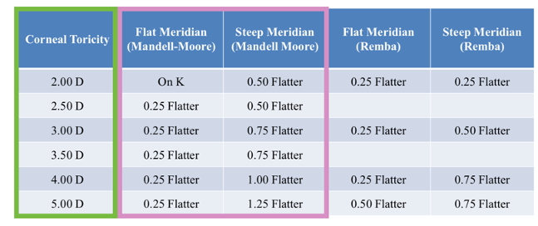

- Indications for large RGP lenses: decentred cones, advanced keratoconus, pellucid marginal degeneration, issues with comfort when wearing RGP lens, post surgical, poor success with alternative measures (e.g., piggyback, comfort). They completely vault over the cornea
- Complications of large RGP lenses: seal off, corneal toxicity, limbal stem cell damage, corneal neovascularisation, generally reserved for advanced cases where they are necessary.There is no tear exchange so has v high dk/t for eyes to stay healthy on long term wear.
- Indications of piggyback: high dk silicone hydrogel, low plus powered soft disposable CL + corneal RGP lens - acceptable fitting with corneal RGP lens but problem corneal abrasion due to apical bearing. Improved comfort for patient who cannot adapt to lens wear. Improving centration
- Hybrid lens- RGP centre with soft CL skirt- achieves best vision through RGP centre and best comfort with soft CL outer. Synergeyes.
- More CL complications
- Corneal Vascularisation: from corneal hypoxia and limbal hyperaemia. Normally immune privilege gets under stress and new vessels develop.
- Corneal infiltrates: chemotactic stimulus for leukocyte invasion may be traumatic, viral, allergic, toxic, or obscure • contact lens-related predisposing factors:– solution preservatives– poor lens fit or condition– toxic environmental stimuli– bacterial endotoxins or exotoxins (e.g. Staphylococcal marginal infiltrates)– etc.... discontinue use, may take a couple months to resolve. Reduce wearing time, change solution, educate about no EW DD better and check for recurrence.
- CLARE: tight lens syndrome or due to endotoxins released by bacteria during closed eye state. more common with chemical forms of lens disinfection. Could be debris trapped behind too- debris trapped behind tight immobile lens– breakdown → release of toxic substances →inflammatory response • substances absorbed into lens polymer– higher incidence with HWC lenses, less frequent replacement schedules. Resolves quite quickly at 48-72 hours after stopping lens wear. 50% recurrence.
- CLPU: inflammatory reaction to bacterial endotoxins or exotoxins– more frequent in gram-positive bacterial carriers– some similarities to staphylococcal marginal ulcers. resumption of lens wear usually successful • modify lens care regimen, encourage compliance • chances of recurrence, as with other inflammatory events

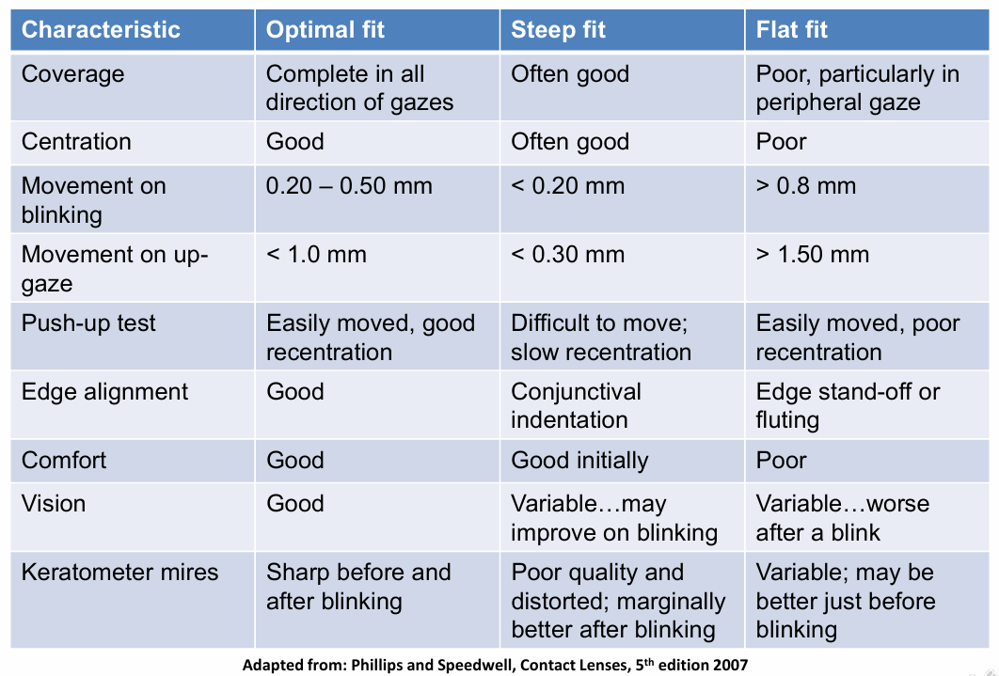
Oxyspet uses tablet while other hydrogen peroxide uses platinum disc. No issues using it with ortho k or with RGPs even though its only for SCLs (essentially it is hydrogen peroxide? anyways)

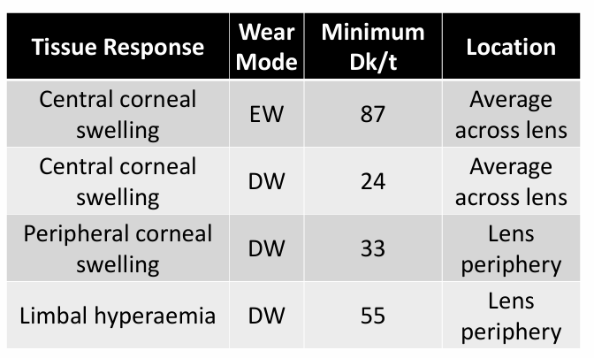

More info
Spherical SCL

DD
Total 1 dk/t 156 BC: 8.5, DIA: 14.1 +6.00 to -12.00, -6.50 to -12.00 in 0.50 steps.
MyDay dk/t 100, BC: 8.4, DIA: 14.2, +8.00 to -12.00. Same as above but +5.50 to +8.0 in 0.50 steps.
Acuvue Oasys Hydraluxe dk/t 121, BC: 8.5, 9.0, +8.00 to -12.00

Fortnightly
Acuvue hydraclear dk/t 143, BC: 8.4, 8.8, DIA: 14.0, +8.00 to -12.00
Coopervision cAIR dk/t 110, BC: 8.4, DIA: 14.2, +8.00 to -12.00

Monthly
Air Optix Night and Day dk/t 175 BC: 8.4, 8.6, DIA: 13.8 +6.00 to -10.00, Only 0.50 steps from -8.50 to -10.00
Air optix plus hydraglyde dk/t is 138, BC: 8.6, DIA: 14.2. +8.00 to -12.00, with +6.50 to +8 in 0.50 steps and -6.50 to -12.00 in 0.50 steps
B&L Ultra monthly dk/t 163, BC: 8.5, DIA: 14.2, +6.00 to -12.00
Biofinity dk/t 171 8.6, DIA: 14.0 +8.00 to -12.00
Acuvue vita dk/t 147, BC: 8.4, 8.8, DIA: 14.0 +8.00 to -12.00
